Uppgift 1

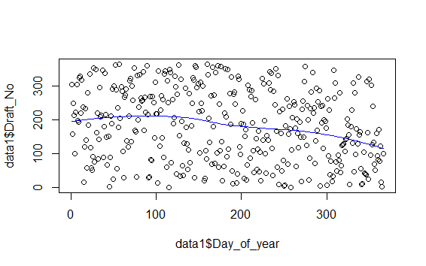

Lottery looks being non-random

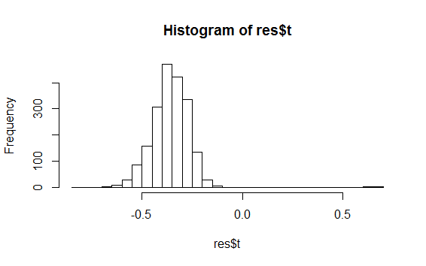

> mean(res$t>0)

[1] 0.002

The hypothesis of T=0 is rejected with a very low p-value.--> according to our hypothesis should imply non-randomness

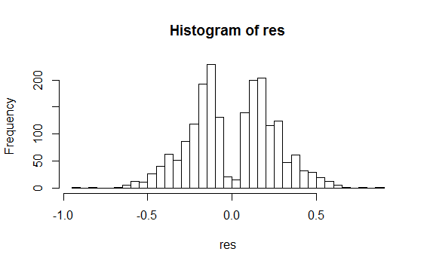

> mean(abs(res)>abs(stat0))

[1] 0.1635

P-value says that we can not reject null-hypothesis, i.e. lottery can be random🡪not so good test statistics chosen?

> reject/100

[1] 0.96

Power seems to be good, but it is based only on simple linear models🡪 can be totally different if we choose nonlinear ones (should not be trusted)-

Uppgift 2

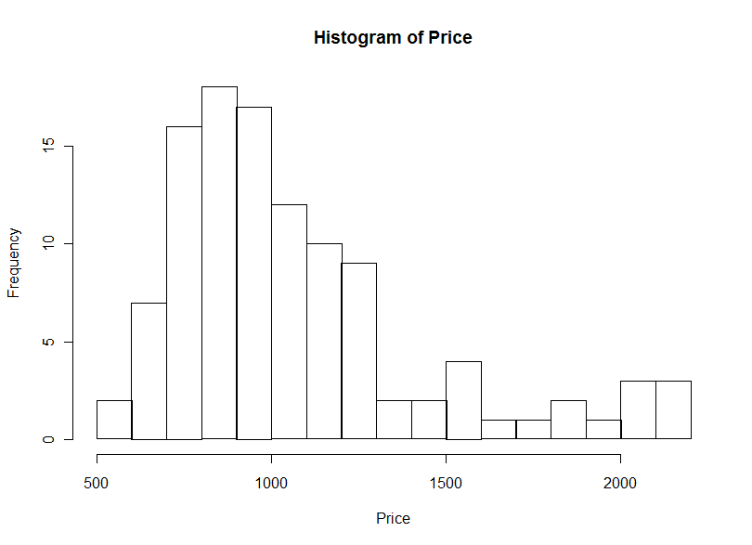

Looks like chi-square or gamma or F distribution

mymean<-function(set, indices) mean(set[indices]);

bootres<-boot(Price,mymean,1000)

plot (bootres)

#bias correction

mycorr <-2\*bootres$t0-mean(bootres$t);

#variance estimate

myvar<-var(bootres$t);

myci <-boot.ci(bootres);

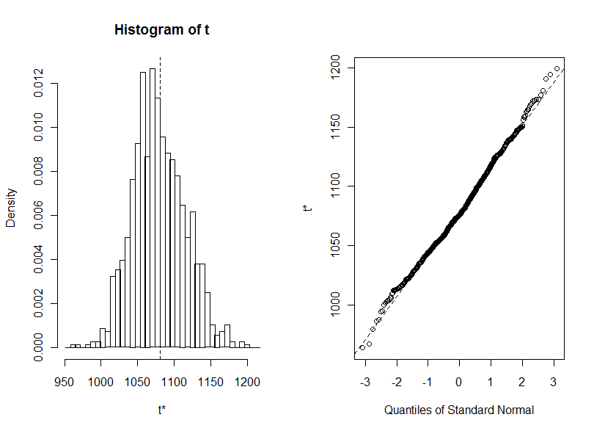

> mycorr

[1] 1081.726

> mean(Price)

[1] 1080.473

> myvar

[,1]

[1,] 1311.131

> myci

BOOTSTRAP CONFIDENCE INTERVAL CALCULATIONS

Based on 1000 bootstrap replicates

CALL :

boot.ci(boot.out = bootres)

Intervals :

Level Normal Basic

95% (1011, 1153 ) (1011, 1147 )

Level Percentile BCa

95% (1014, 1150 ) (1022, 1170 )

Calculations and Intervals on Original Scale

Mean is located inside all intervals, BCa shifted to the right of Percentile

#jack

r<-length(Price);

T<-rep(0,r);

for (i in 1:r) {

T[i]=r\*mean(Price)-(r-1)\*mean(Price[-i]);

}

JT=mean(T);

varJack=sum((T-JT)^2)/(r\*(r-1));

> varJack

[1] 1320.911

Variance is greater than var estimated by bootrstrap(it is often overestimated)